Joint Meeting in Brussels (3rd and 4th of May 2018): How to get there?
- Meeting Venue
- Royal Flemish Academy of Belgium for Sciences and the Arts (website) – Paleis der Academiën – Palais des Academies.
- The venue is located next to the Belgian Royal Palace and in walking distance of the Brussels Grand-Place and The Saint Michael’s Cathedral.
- The venue is easily accessible through public transport (Brussels Central Train Station within one km of the venue; Metro Troon or Metro Park station within a few 100 m; Bus stops within 100 m of the venue)
- Map of the area:

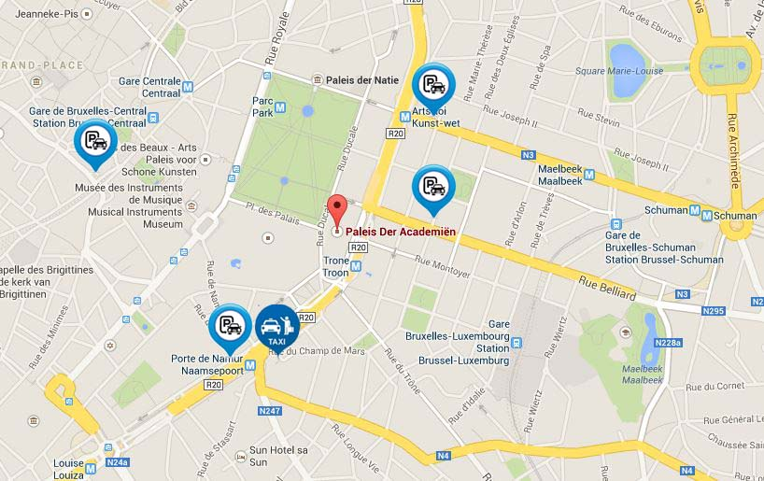

- Conference dinner (Thursday 3rd May)
- The social event on Thursday evening will be organized at the Coudenberg Palace, which is a 500 m walk from the Meeting venue.

- Hotels
  - The meeting venue is in the City Centre of Brussels, and a selection of hotels is available in a wide price range.
  - You can find a suitable hotel via google, via booking.com or via trivago

- Getting there
By plane:
- through Brussels National Airport
- through Brussels South Charleroi Airport (1h trip from Brussels Capital)
By train:
- International trains to Brussels Midi Station.

- Some tourist information and museums in Brussels
- Visit a city
- Visit Brussels
- Horta Museum
- Fine Arts Museum
- Museum of Natural Sciences
- Musical Instruments Museum
- Bozar
- Cantillon Brewery

